Press Information

STRICTLY UNDER EMBARGO UNTIL 8.30AM CET AUGUST 29 2016

August 29, 2016

Philips Hue broadens its reach into homes with new lamps and bulbs

- Philips Lighting launches range of Philips Hue white ambiance lamps and adds new spot light to range of bulbs
- Popular Philips Hue white and color ambiance A60 (E27 and B22) bulb now even better

Amsterdam, Netherlands – Philips Lighting (Euronext Amsterdam ticker: LIGHT), a global leader in lighting, today announced the launch of a new range of stylish lamps that incorporate Philips Hue white ambiance bulbs, enabling you to select the best shade of white light to suit your daily routines, anywhere in the home. New additions within the Philips Hue family also include a Philips Hue white ambiance GU-10 spot light, which provides a perfect fit for lighting across the home, and the original Philips Hue white and color ambiance A60 (E27 and B22) bulb just got even better, with more intense colors.

New lamps with Philips Hue white ambiance built in
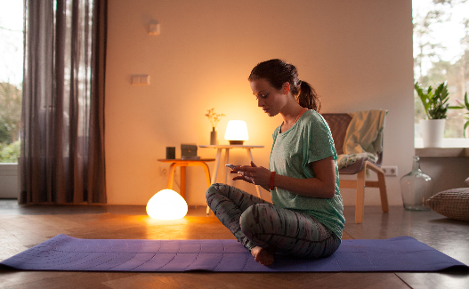
Philips has launched a new range of stylish lamps that come integrated with, or supplied with, Philips Hue white ambiance bulbs. The lamps provide beautiful, white light to transform your home. Pick a shade of white that’s right for you; whether it’s light to relax and prepare you for a calming yoga session, or a cool, bright light, perfect for that final mirror check before heading out with friends. Choose from elegantly designed pendants, ceiling and wall lamps, table lamps and spots to create the perfect mood in every room or to provide a striking interactive centerpiece.

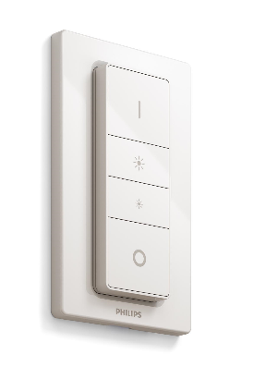
For simplicity of control, each Philips Hue white ambiance lamp comes with a portable wireless Philips Hue dimmer switch which is pre-programmed with four Light Recipes to support you through your day: Relax, Read, Concentrate and Energize. The lamps work straight out of the box with instant control - without the need for an internet connection - meaning everyone in the family can use them. Designed for function, as well as style, the lamps put the full white light spectrum at your fingertips; from cool daylight (6500k) to warm white (2200k).

“The Philips Hue white ambiance lamps enable our customers to experience the benefits of controllable white light - to help feel energized, wind down at night, or simply to set the perfect ambiance to suit their mood,” explains Sridhar Kumaraswamy, Business Leader Home Systems at Philips Lighting. “With Philips Hue white ambiance built-in, they deliver the high quality light you need, when you need it, as you go through your daily routines in your home.”

Introducing the ‘perfect fit’ Philips Hue white ambiance spot light
The Philips Hue white ambiance range has also been extended to include a GU-10 spot light, which fits flush into ceilings and sockets. The ‘perfect fit’ spot light is fully dimmable and, like all Philips Hue white ambiance bulbs, can be controlled in many ways. These include via the Philips Hue wireless dimmer switch, with four pre-set Light Recipes, through the Philips Hue app, your voice, wearables, and now with your presence, by using the new Philips Hue motion sensor.

The full benefits of Philips Hue
You can take the connectivity of your lamps in your home even further. When used with the Philips Hue bridge, the new Philips Hue white ambiance lamps and spot light can be controlled by the Philips Hue app which has a ‘Routines’ function. Using the ‘Wake up’ setting your spot lights in your bedroom can imitate the rise of the sun, slowly increasing in brightness to wake you up more naturally. Replicating the sun setting, the ‘Go to sleep’ routine gradually dims until it is off, preparing your body for falling asleep. For those with young children who have to get up in the night, ‘Nightlight’ is a new light setting that delivers a low level of light while also minimizing exposure to blue light, lessening the disturbance to your sleep cycle.

Color just got richer
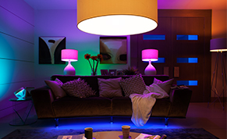
The Philips Hue white and color ambiance A60 (E27 and B22) now has improved color rendering, offering limitless possibilities. When synced to your TV, watching movies or playing video games becomes even more immersive as the improved color spectrum, with richer greens and blues, helps to further bring to life the action on screen. For further entertainment, sync the bulb to your music and, through third-party apps, deeper engross yourself in a multisensory experience. With 16 million colors in the Philips Hue app to choose from, it’s never been a better time to get creative with light.

Delivering the best lighting experience for the home is at the heart of Philips Hue, and the key to this is being interoperable with apps, products and platforms from other brands and developers. Philips Hue works seamlessly with Amazon Alexa (in the US), Apple HomeKit, Nest, Bosch (in Germany), Samsung SmartThings and other smart home devices and wearables to truly transform how you experience and interact with light in your home.

Coming to a store near you
The new Philips Hue white ambiance lamps are expected to be available in Europe by end of October, 2016 and the GU-10 spot light is expected to be available in selected markets in Europe and North America by end of October, 2016.

The Philips Hue white and color ambiance A60 (E27 and B22) is expected to be available in starter kits, and individually, in selected markets in Europe and North America by end of October, 2016.
Philips Lighting at IFA
The Philips Press Conference takes place on September 1 at 12.15pm in Hall 22, Messe Berlin. The live stream of the event can be seen at www.ifa.philips.com. Chris Worp, Head of Business Group Home from Philips Lighting, will be presenting alongside Pieter Nota, CEO Personal Health Businesses and Chief Marketing Officer at Philips and Kostas Vouzas, Senior Director Business EMEA at TP Vision.

For further information on the latest Philips Lighting innovations at IFA 2016, please visit www.ifa.philips.com, follow Philips Lighting at IFA on twitter @PhilipsLight, or visit our additional social media channels on YouTube and LinkedIn.

-ENDS-

For further information, please contact:
Philips Lighting
Paula den Dunnen
paula.den.dunnen@philips.com

About Philips Lighting
Philips Lighting (Euronext Amsterdam ticker: LIGHT), a global leader in lighting products, systems and services, delivers innovations that unlock business value, providing rich user experiences that help improve lives. Serving professional and consumer markets, we lead the industry in leveraging the Internet of Things to transform homes, buildings and urban spaces. With 2015 sales of EUR 7.5 billion, we have approximately 36,000 employees in over 70 countries. News from Philips Lighting is located at http://www.newsroom.lighting.philips.com

